1. Write an HTML script to demonstrate how to change the content dynamically using HTML JavaScript.

<!DOCTYPE html>

<html lang="en">

<head>

    <meta charset="UTF-8">

    <meta name="viewport" content="width=device-width, initial-scale=1.0">

    <title>Dynamic Content</title>

</head>

<body>

    <p id="Soham">Hello, I am Soham Patel</p>

    <button onclick="changecontent();">Changing content Dynamically</button>

    <script type="text/javascript">

        function changecontent()

        {

            document.getElementById("Soham").innerHTML="Well, I am the student of Blockchin Developer."

        }

    </script>

</body>

</html>

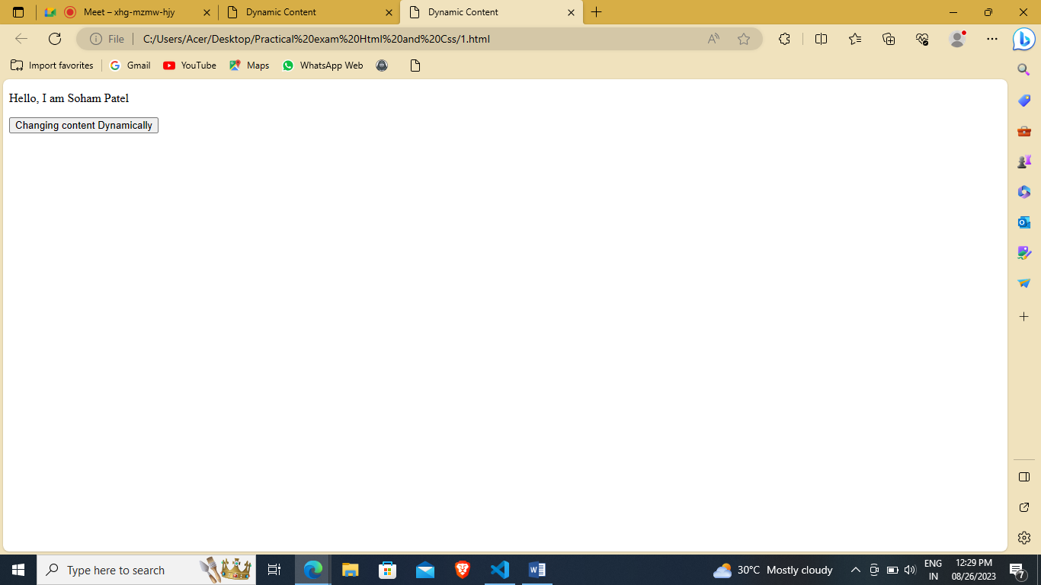

After Click Setence is Change:

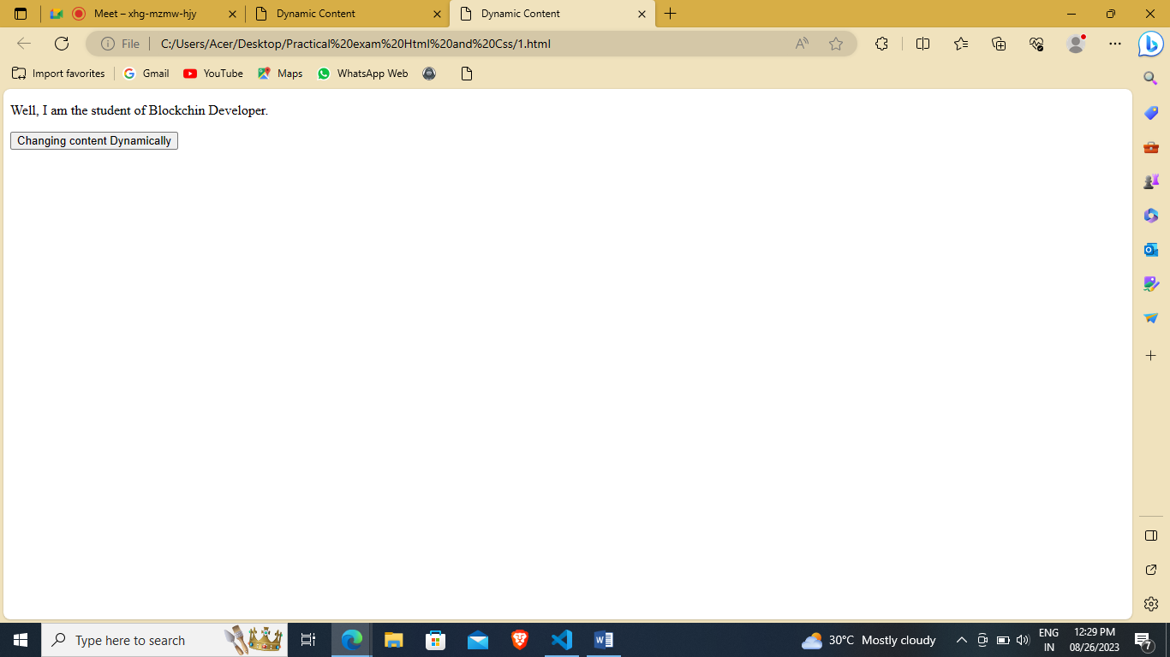

1. Write an HTML script to demonstrate how to change the styles using HTML JavaScript.
2. <!DOCTYPE html>
3. <html lang="en">
4. <head>
5. <meta charset="UTF-8">
6. <meta name="viewport" content="width=device-width, initial-scale=1.0">
7. <title>Style Content</title>
8. </head>
9. <body>
10. <p id="Soham">Hello, I am Soham Patel</p>
11. <button onclick="changecontent();">Changing content Dynamically</button>
12. <script type="text/javascript">
13. function changecontent()
14. {
15. document.getElementById("Soham").style.fontSize="60px";
16. document.getElementById("Soham").style.fontStyle="italic";
17. document.getElementById("Soham").style.color="red";
18. }
19. </script>
20. </body>
21. </html>

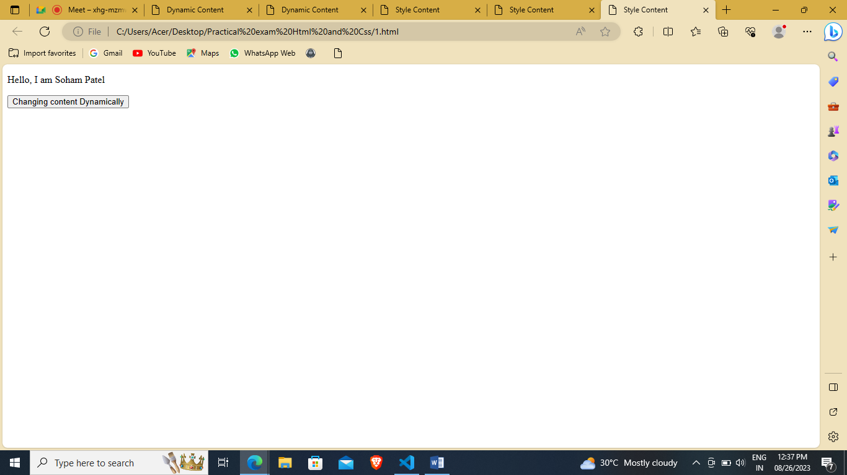

After click change color, size and style.

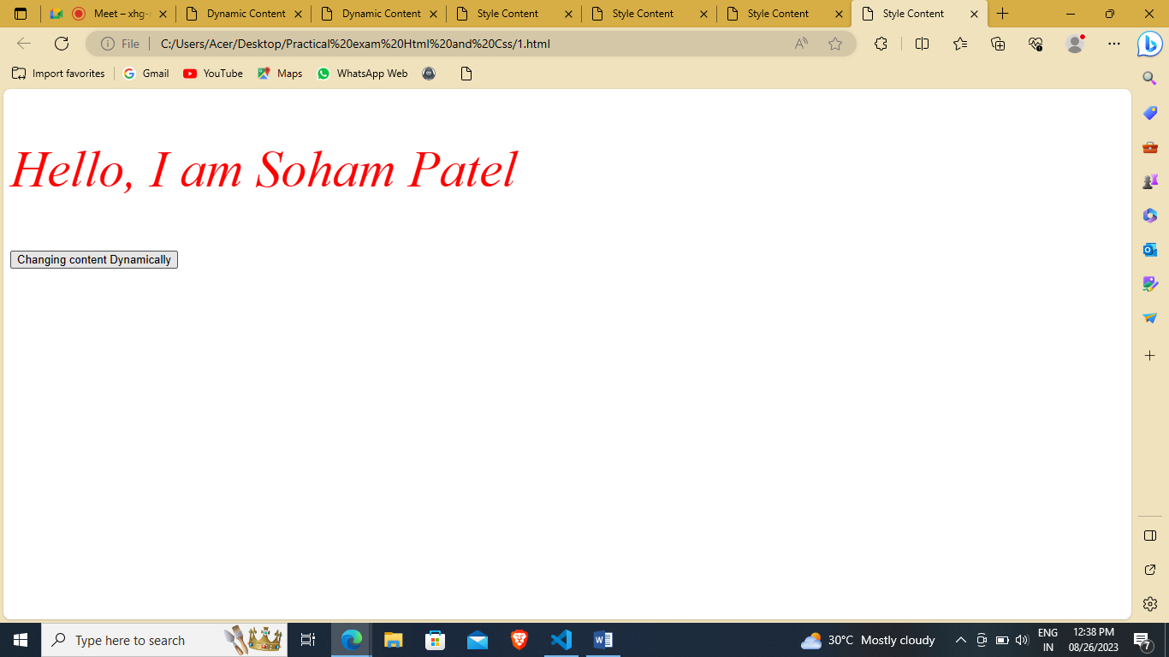

3. Write an HTML script to demonstrate how to hide and show the content using HTML JavaScript.

<!DOCTYPE html>

<html lang="en">

<head>

    <meta charset="UTF-8">

    <meta name="viewport" content="width=device-width, initial-scale=1.0">

    <title>Hide and Show Content</title>

</head>

<body>

    <div id="Soham" style="width: 150px; height: 150px; background-color: yellow; border: 10px solid black;"></div>

    <button onclick="show();">Soham Patel</button>

    <button onclick="hide();">Babu </button>

    <script type="text/javascript">

        function show()

        {

            document.getElementById("Soham").style.display="block";

        }

        function hide()

        {

            document.getElementById("Soham").style.display="none";

        }

    </script>

</body>

</html>

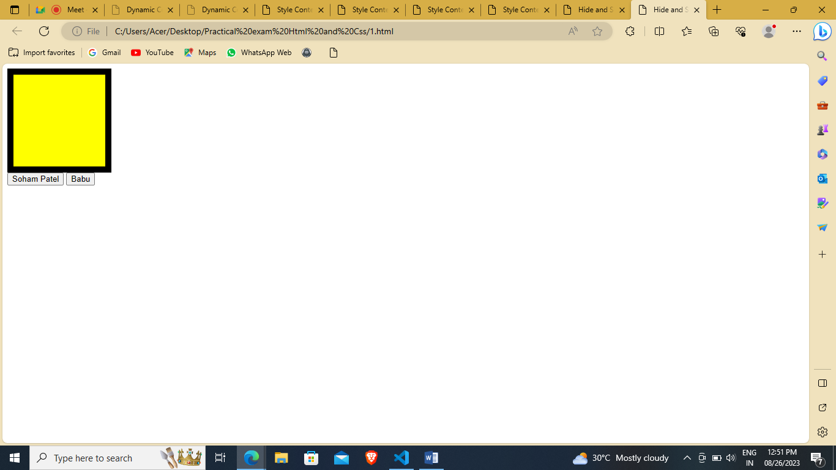

After click hide.

